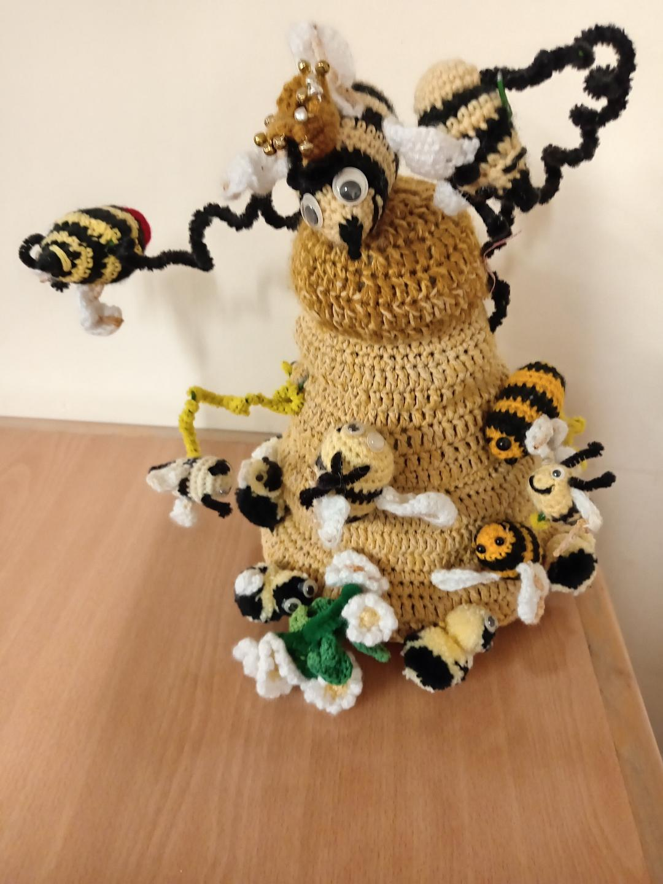

**ST.PAUL’S CHURCH YOUTH COUNCIL**

The focus for our February meeting was ‘Ethical Marketing’ as we prepare for our bees to emerge from their winter hibernation and hopefully, later in the year, our first honey harvest. We were delighted to welcome Dani, a local Commercial Marketing Director who guided us through our design and decision process. The CYC were terrific, coming up with fabulously creative ideas and displaying confidence and maturity when sharing them. Mood boards, strap lines and potential jar labels were discussed and we are now in the process of putting our ideas together to create a final design. We will keep you informed of our progress.

Two new members were warmly welcomed and a huge thank you must go to Jean for a delicious pasta bake which kept everyone sustained and working.

**Future events and meetings**

**Thursday March 6th** Sue Knights from the Bee Society. 6 pm in The Lodge

**Thursday April 3rd.** Personal Safety. 6pm at The Lodge

**Saturday April 12th.** Car Wash at The Parish Church . 10 am to 1pm.

**Sunday April 27th.** CYC Bacon & Egg Breakfast. 9.30 Church Centre

**Thursday May 1st** Topic tbc 6 pm in The Lodge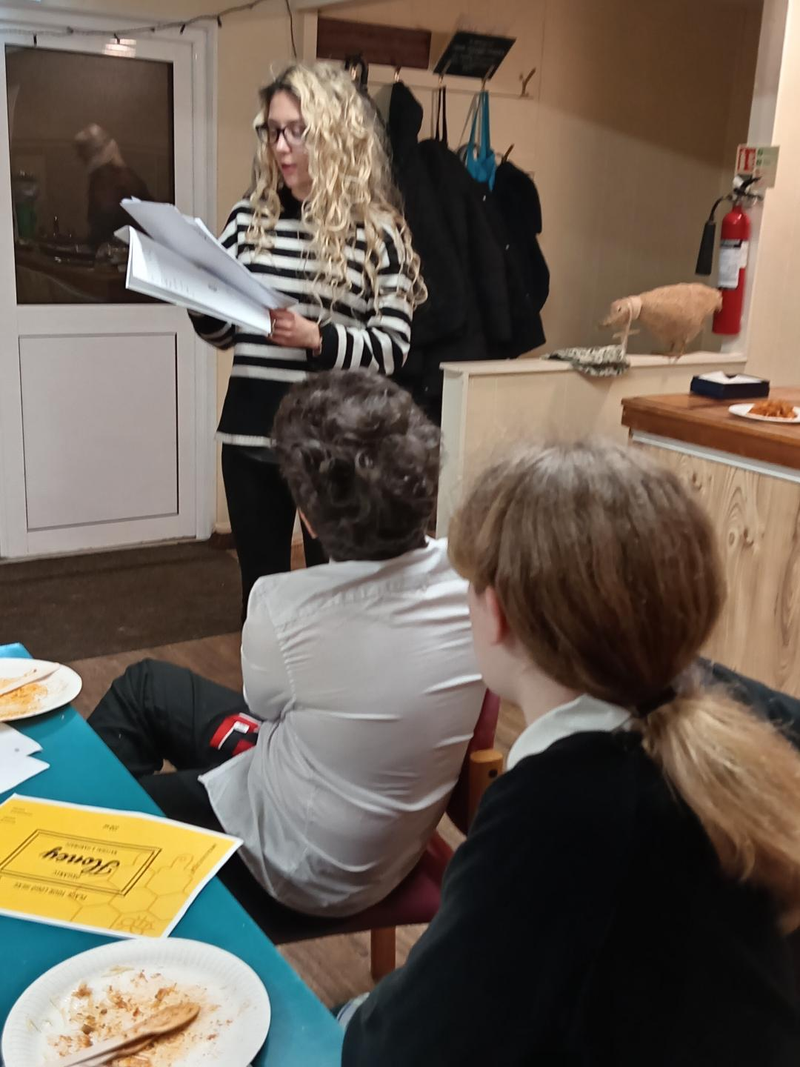

**Monday 5th May.** Parish Walk

The CYC welcomes all children of secondary school age. Please see our web page on the Church website for all details of the Youth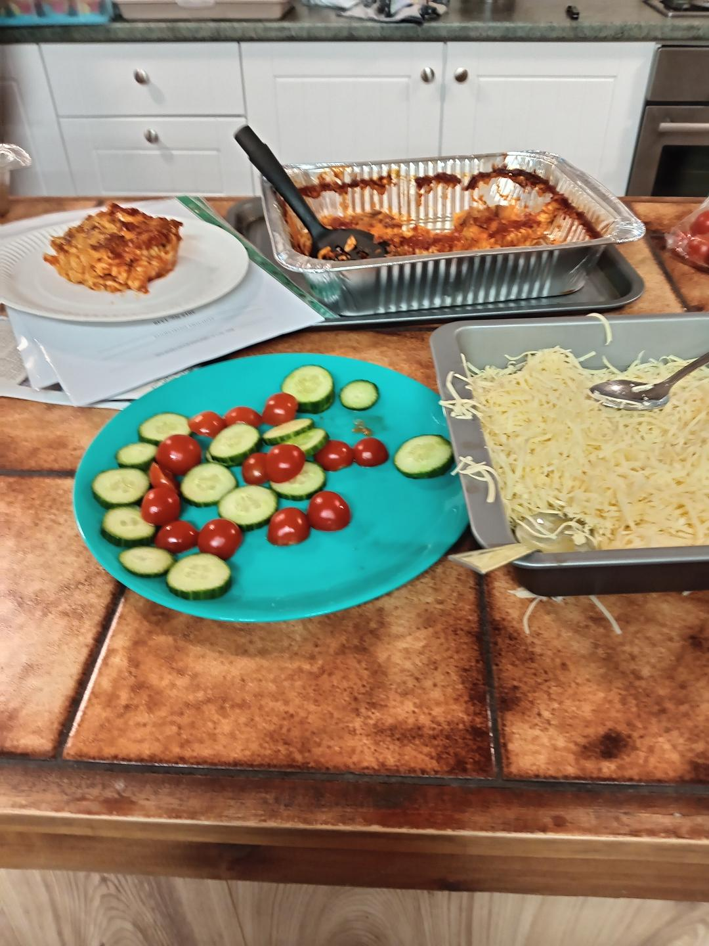 Council.